Week 9 & 10 Excercise
TSA Complaints
Tejashri Bhilare
MS in Data Science, Bellevue University
DSC640 – Data Presentation and Visualization
Professor - Catie Williams
February, 2025

Data Story Telling : TSA Complaints

1. Audience & Purpose
Audience:
- Who: TSA senior leadership and operations managers.
- Data Familiarity: They possess a strong understanding of operational data, performance metrics, and industry jargon, so we can use technical language and detailed visualizations.
- Insight Level: They are interested in actionable insights that can lead to operational improvements and enhanced passenger experience.

Purpose:
- Key Message: Our analysis reveals significant trends in complaint frequencies and categories across various airports.
- Call to Action: We recommend launching a pilot program focused on improving areas with the highest complaint counts—through targeted operational changes and enhanced customer service initiatives—to ultimately improve the TSA experience.
- Outcome: The intended outcome is for leadership to approve targeted interventions at high-complaint airports and monitor the effects over the next quarter.

2. Medium & Design Strategy
Medium:
- Presentation Format: An interactive dashboard integrated into a PowerPoint presentation
- Interactivity: The dashboard will allow executives to drill down by airport, complaint category, and even view trends over time, making it easier to identify specific issues.

Design Principles (Informed by Gestalt’s Theories):
- Color:
  - Usage: A contrasting color scheme where high complaint counts are highlighted in bold colors (e.g., red or deep orange) against neutral backgrounds to immediately draw attention.
  - Consistency: Each complaint category will have a unique color consistently applied across all visuals.
- Text:
  - Clarity: Headings, labels, and annotations are concise, with key numbers bolded for quick interpretation.
  - Hierarchy: Important insights are presented in larger fonts, while supporting details use smaller type, ensuring that the most critical information stands out.
• Alignment & Spacing:
- Layout: Visuals and text are aligned to create a clean, grid-like structure that guides the eye naturally from the general overview to detailed insights.
- White Space: Sufficient spacing around charts and sections prevents visual clutter and enhances focus.
• Sizing:
- Emphasis: Key data points (such as outlier airports with significantly higher complaint counts) are enlarged or emphasized via dynamic sizing in the dashboard, ensuring they immediately capture attention

Let’s explore some visualziations for this everyday’s TSA journey.

1) Title: Turning Up the Heat on TSA Complaints

Imagine a map that doesn’t just show numbers—it tells a story. Our heatmap of TSA complaints by subcategory and airport does exactly that, revealing a vibrant narrative hidden within the data.
The Story Unfolds:
Each airport is a chapter in our story, and every complaint subcategory is a subplot.

What the Heatmap Reveals:
At a glance, the heatmap pinpoints where our focus should be:
- Hot Zones: Airports that consistently show high complaint counts across multiple subcategories signal potential systemic issues. They are the areas where a deeper dive is necessary to understand the underlying causes.
- Cool Zones: Airports with lower complaint intensities might be serving as benchmarks for best practices. They offer insights that could be replicated elsewhere.

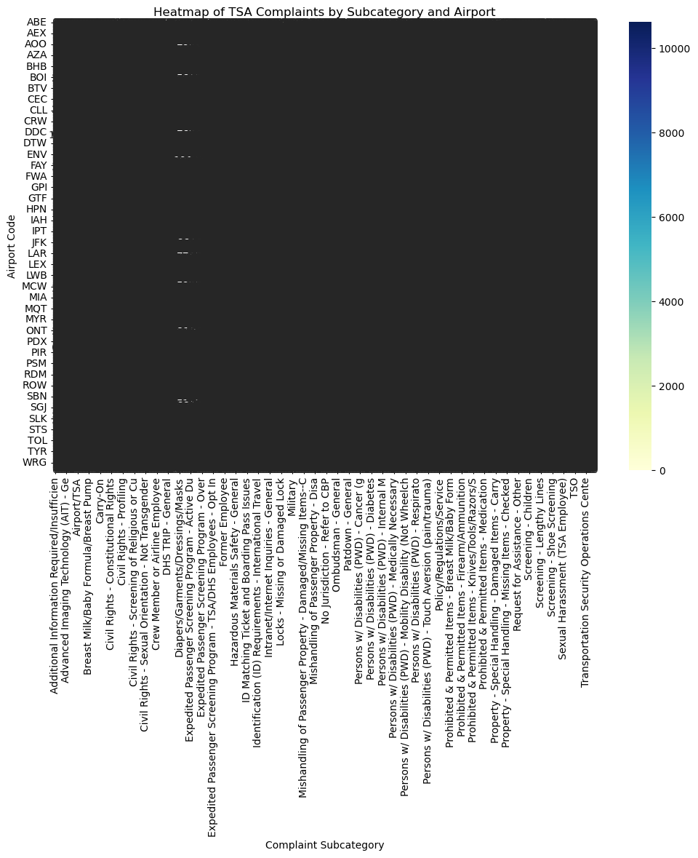

From Insight to Action:
This isn’t just about identifying problem areas—it’s about igniting change. With this clear visual, decision-makers are empowered to:
- Investigate the Hotspots: Deploy targeted audits, engage frontline staff, and connect with passengers to understand the root causes.
- Celebrate and Learn from the Cool Zones: Recognize effective strategies and processes that keep complaint counts low, and consider these as models for improvement elsewhere.
Call to Action:
Let this heatmap be the spark that fuels a comprehensive review of TSA operations. By focusing on the red-hot areas, we can innovate our service protocols, streamline operations, and ultimately enhance the passenger experience.
The data tells us where the pressure points are—now, it’s time to act on them.

2) Title: Uncovering the Passenger Pulse: A Bar Chart Story of TSA Complaints
Imagine a visual where every bar speaks the language of the traveler. In our bar chart, each bar represents a distinct category of TSA complaints, vividly illustrating the frequency of issues experienced by our passengers.
- The Tallest Bars Tell a Story:
The categories with the highest complaint counts immediately draw your attention. These are the areas where our service may be falling short—perhaps long wait times or confusing procedures—signaling urgent areas for improvement.
- The Shorter Bars Provide Balance:
Conversely, the categories with fewer complaints showcase where our current practices are effective, offering us models for success that could be replicated in other areas.
- A Clear Call to Action:
This bar chart isn’t just a static display of numbers; it’s a dynamic snapshot of the passenger experience. By zeroing in on the high complaint categories, we have a clear mandate: investigate these pain points, allocate resources effectively, and turn critical feedback into actionable improvements.

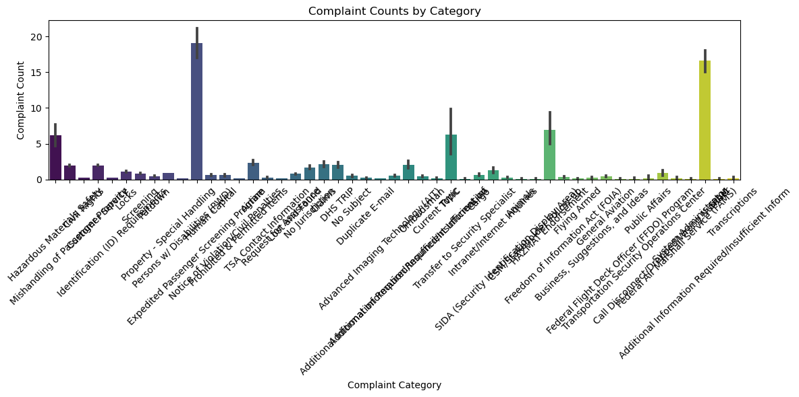

Title: "Peeking Under the Hood: Uncovering the True Story Behind TSA Complaints"
Imagine each airport as a unique machine, with its own rhythm and quirks. This box plot doesn’t just show raw numbers—it reveals the hidden story behind TSA complaint counts for each airport. Here’s how to read it:
- The Median Line:
Think of it as the heartbeat of an airport. It tells us the typical complaint experience that most passengers encounter. A higher median might signal persistent issues, while a lower one suggests smoother operations.
- The Box Itself:
This represents the range in which most complaints fall. A narrow box indicates consistency in performance—either consistently good or consistently needing attention. A wider box reveals more variability, suggesting that while some days are calm, others might be stormy.
- The Comparative Story:
By placing airports side by side, this visualization allows us to quickly spot which locations are performing reliably and which ones are outliers. It gives us a clear roadmap for where to dig deeper and where to replicate best practices.
The Call to Action:
This box plot is more than just a snapshot—it's a diagnostic tool. By examining the consistency and variability of complaints, decision-makers can pinpoint where improvements are needed most urgently. Let’s use these insights to target interventions, streamline operations, and ultimately elevate the passenger experience across all airports.

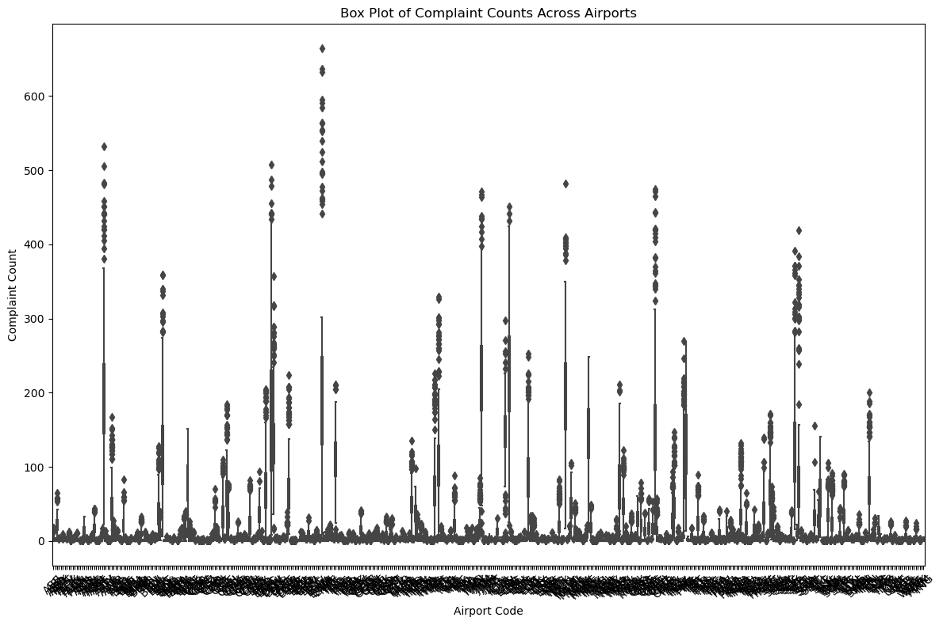

The World's Gateway: A Tale of Airports and Global Connections

Imagine a world where every airport is a portal, a gateway to new adventures, opportunities, and stories waiting to unfold. From the sprawling mega-hubs of the United States and China to the isolated airstrips dotting tiny island nations, each airport represents a lifeline of connectivity.
As you gaze upon this choropleth map, colors bring to life the density of air travel across the globe. Countries with deep, rich hues are bustling aviation giants—each dot on the map symbolizing a human journey, a heartfelt reunion, or the promise of something new.

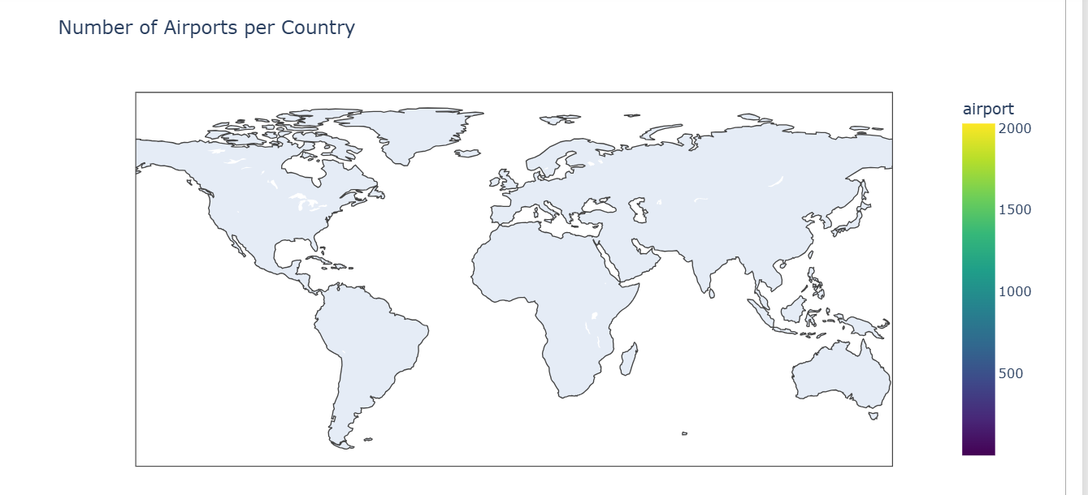

This map is more than a data visualization; it is a story of movement, ambition, and human connection. The more airports a country has, the more interconnected its people are. Every takeoff represents a dream in motion, and every landing marks the end of one chapter and the beginning of another.
As you explore this map, ask yourself—where will your next journey take you?

Custom visuals.

  - Bar Chart – Complaints by Category

"Turning Complaints Into Clarity—Category by Category."

In the world of customer service, every complaint tells a story—a moment where expectations weren’t met, where frustration outweighed satisfaction. The Bar Chart – Complaints by Category pulls back the curtain, revealing the recurring pain points that customers face.

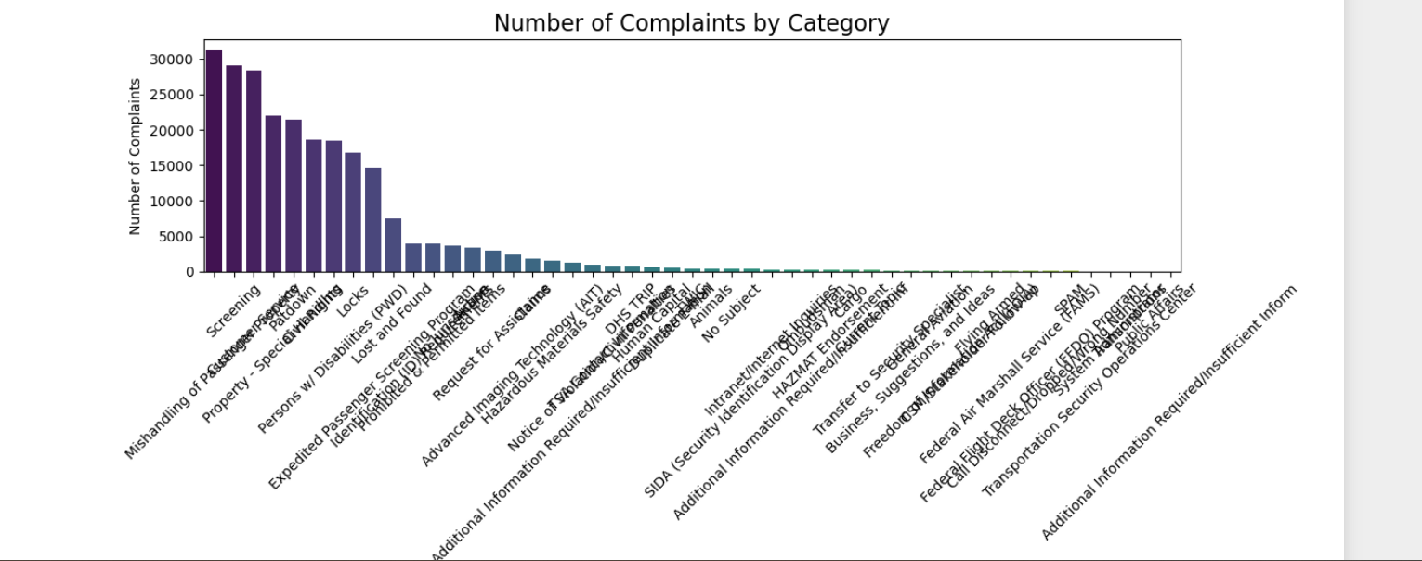

  - Pie Chart – Complaint Distribution

- "Every Slice Tells a Story—Which Complaint Takes the Biggest Bite?"

Imagine every customer complaint as a voice in a crowded room—some louder, some softer, but all demanding to be heard. The Pie Chart – Complaint Distribution takes this noise and turns it into a clear picture, revealing where the loudest concerns truly lie.

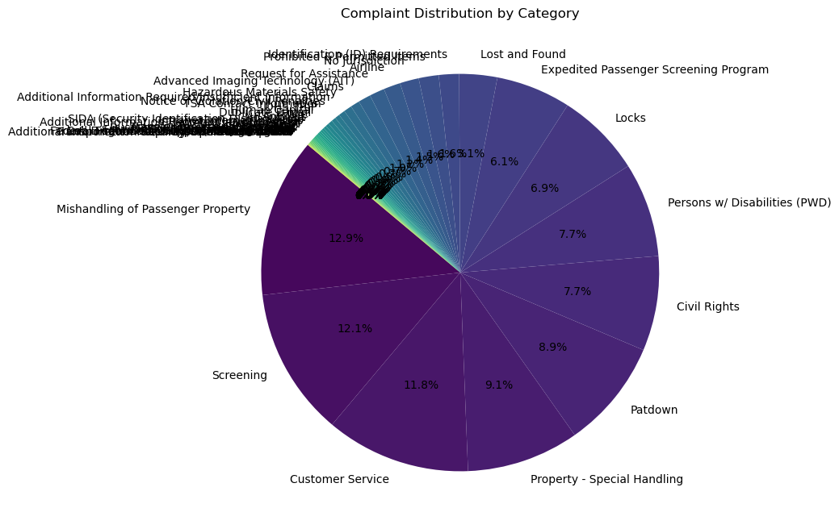

Ethical Considerations
- Data Transformation & Transparency:
  - Changes: Data from the three datasets was merged using the airport code to provide a cohesive view. Aggregations were performed to ensure individual identities remain anonymous.
  - Documentation: All filtering (e.g., removing duplicate records or outliers) is clearly documented in an accompanying methodology report to maintain transparency.
- Legal & Regulatory Guidelines:
  - Compliance: The data used is publicly available and has been handled in strict accordance with TSA and governmental data privacy policies.
  - Disclosure: Any transformations made for visualization (such as scaling or anonymizing data) are clearly disclosed to avoid any misinterpretation.
- Risk Mitigation:
  - Bias & Assumptions: Acknowledging that our cleaning process and any data filtering can introduce bias, we recommend ongoing audits and validations of the underlying datasets.
  - Assumptions: Any assumptions made during data processing (e.g., assuming consistent categorization across datasets) are noted to ensure stakeholders understand the basis of our conclusions.
- Data Credibility & Ethics:
  - Source Verification: The datasets originate from official TSA records, which have been cross-verified against internal audit reports.
  - Ethical Sourcing: The data was acquired ethically, ensuring compliance with all relevant legal frameworks.
  - Mitigation: We propose regular updates to the analysis and external audits to mitigate any potential ethical concerns, ensuring that the visuals and recommendations remain fair and objective.

Conclusion & Call to Action
This data story paints a clear picture: several airports show concentrated areas of high complaint volumes, and specific complaint categories consistently emerge as problematic. By leveraging our interactive dashboard and robust visualizations, we can now target operational improvements where they are most needed.
Call to Action:
- Pilot Program Implementation: Approve a pilot program in the top 10 airports with the highest complaint densities, incorporating customer service training and process optimizations.
- Ongoing Monitoring: Establish a task force to regularly update and review these dashboards, ensuring timely responses to emerging trends.
- Cross-Department Collaboration: Engage both operational teams and customer experience specialists to refine the interventions based on real-time data insights.
This initiative not only aims to reduce complaint volumes but also to enhance the overall travel experience, ensuring TSA continues to deliver secure and efficient service.

